
DAS_________
TOPICAL QUESTIONS FOR P.7 TERM 1 2019
SCIENCE NO. 1
School…………………………………………………………………………………………………………………
Name: ……………………………………………………………… Stream: …………………………………

TOPIC: MUSCULAR – SKELETAL SYSTEM
- What is a skeleton?
………………………………………………………………………………………………………………………………
- State anyone function of the human skeleton.
………………………………………………………………………………………………………………………………
- Write down anyone type of skeleton.
………………………………………………………………………………………………………………………………
- State the most essential mineral salts needed for proper growth and development of bones and teeth.
………………………………………………………………………………………………………………………………
- Explain the importance of the cartilage structure found in the outer ear of most mammals?
……………………………………………………………………………………………………………………………..
- Name anyone main part of the human body.
………………………………………………………………………………………………………………………………
- Which delicate body organ is protected by the cranium?
……………………………………………………………………………………………………………………………..
- Give one value of the skeletal system to the circulatory system.
……………………………………………………………………………………………………………………………..
- How does ball and socket differ from hinge joint in terms of movement?
……………………………………………………………………………………………………………………….........................................................................................................................................
- How are muscles connected to bones in the body?
…………………………………………………………………………………………………………………………….
- State the value of the ligament at a joint?
…………………………………………………………………………………………………………………………….
- Name any two types of joints in the human body.
- …………………………………………………………………………………………………………………….
- ……………………………………………………………………………………………………………………..
- State the value of synovial fluid at a joint.
………………………………………………………………………………………………………………………….

- Give anyone example of a voluntary muscle in the human body.
…………………………………………………………………………………………………………………………….
- What are voluntary muscles?
……………………………………………………………………………………………………………………………………………………………………………………………………………………………………………………………..
- State the value of good posture to an individual.
………………………………………………………………………………………………………………………………
- Write down any two diseases which affect the skeletal system.
- ………………………………………………………………………………………………………………………
- ………………………………………………………………………………………………………………………
- Name the deficiency disease which affects the skeletal system.
…………………………………………………………………………………………………………………………….
- Write down any four disorders of the skeletal system
- ……………………………………………………………………………………………………………………..
- …………………………………………………………………………………………………………………….
- ……………………………………………………………………………………………………………………..
- ……………………………………………………………………………………………………………………..
- Which part of the skeletal system protects;
- The heart and the lungs
……………………………………………………………………………………………………………………….
- The brain
………………………………………………………………………………………………………………………
- The spinal cord
……………………………………………………………………………………………………………………..
- The reproductive organs
……………………………………………………………………………………………………………………..
- What is dislocation?
……………………………………………………………………………………………………………………………………………………………………………………………………………………………………………………………..
- What is a fracture?
…………………………………………………………………………………………………………………………….
- Name one activity that can maintain the healthy conditions of the skeletal system?
…………………………………………………………………………………………………………………………….
- Name any two short bones from which red blood cells are made?
- ……………………………………………………………………………………………………………………….
- ……………………………………………………………………………………………………………………….

- Identify one water borne disease of the skeletal system.
……………………………………………………………………………………………………………………………..

- The diagram below shows the human arm, use it to answer the questions that follow
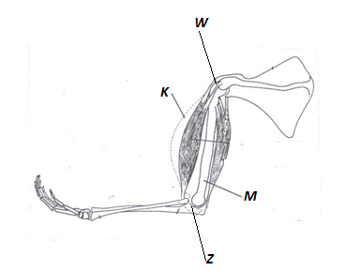

- Name the parts marked K and M
K …………………………………………………… M: ……………………………………………………..
- Name the kind of movement possible at W and Z
W: …………………………………………………………………………………………………………………….
Z: ……………………………………………………………………………………………………………………..

DAS____________
TOPICAL QUESTIONS FOR P.7 TERM 1 2019
SCIENCE NO. 2
School…………………………………………………………………………………………………………………
Name: ……………………………………………………………… Stream: …………………………………
TOPIC: ELECTRICITY AND MAGNETISM
- What is matter?
………………………………………………………………………………………………………………………………………………………………………………………………………………………………………………………………
- What is matter made up of?
…………………………………………………………………………………………………………………………..
- How does mass differ from volume?
……………………………………………………………………………………………………………………………………………………………………………………………………………………………………………………………..
- Give anyone advantage of using electricity for cooking.
……………………………………………………………………………………………………………………………………………………………………………………………………………………………………………………………..
- What is the function of a fuse in an electric circuit?
……………………………………………………………………………………………………………………………..
- How does a fuse work?
……………………………………………………………………………………………………………………………………………………………………………………………………………………………………………………………..
- How can short circuits be prevented?
……………………………………………………………………………………………………………………………..

Below is an electric circuit diagram, use it to answer the questions that follow
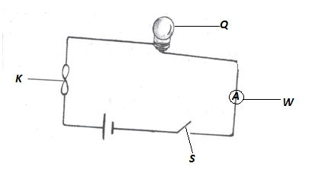

- Name the parts marked S and W
S: ………………………………………………. W: ………………………………………………………
- Give the function of part marked K in the circuit.
………………………………………………………………………………………………………………………………
- Name any two energy changes that take place in part Q when S is closed?
- ……………………………………………………………………………………………………………………….
- ……………………………………………………………………………………………………………………….
- How is part K similar to parts S in terms of function?
…………………………………………………………………………………………………………………………….
- What type of energy is stored in part Q?
…………………………………………………………………………………………………………………………..
- Name any two forms of energy produced at Q when the circuit has been completed?
- ……………………………………………………………………………………………………………………
- …………………………………………………………………………………………………………………….
- Using arrows on the diagram, show the flow of current.
- Name an example of static electricity in nature.
……………………………………………………………………………………………………………………………
- What force enables the type named above to happen?
……………………………………………………………………………………………………………………………
- Why is the bulb filament made coiled?
……………………………………………………………………………………………………………………………..
- Name one device that converts electrical energy into mechanical energy?
…………………………………………………………………………………………………………………………….
- How does electricity generated at Jinja get to a consumer in Kasese town?
………………………………………………………………………………………………………………………….
- Why is it that most conducting wires are made of copper and aluminum not silver yet it is the best conductor?
……………………………………………………………………………………………………………………………………………………………………………………………………………………………………………………………..
- Why should electricity wires be properly insulated?
……………………………………………………………………………………………………………………………..
- Define the term magnetism?
……………………………………………………………………………………………………………………………..
- Give any two properties of a magnet?
- ………………………………………………………………………………………………………………………
- ………………………………………………………………………………………………………………………
- How can electromagnets be made stronger?
…………………………………………………………………………………………………………………………….
- In what way is a magnet useful to a doctor in a hospital?
…………………………………………………………………………………………………………………………………………………………………………………………………………………………………………………………….
- State any three ways of demagnetizing a magnet?
- ……………………………………………………………………………………………………………………..
- …………………………………………………………………………………………………………………….
- ……………………………………………………………………………………………………………………..

DAS_____________
TOPICAL QUESTIONS FOR P.7 TERM 1 2019
SCIENCE NO. 3
School…………………………………………………………………………………………………………………
Name: ……………………………………………………………… Stream: …………………………………

TOPIC: ENERGY RESOURCES
- What is a resource?
………………………………………………………………………………………………………………………………………………………………………………………………………………………………………………………………
- Define the following terms;
- Energy
………………………………………………………………………………………………………………………………………………………………………………………………………………………………………………
- Energy resource
………………………………………………………………………………………………………………………………………………………………………………………………………………………………………………
- Give any one reason why plants are regarded as energy resources?
………………………………………………………………………………………………………………………………………………………………………………………………………………………………………………………………
- Identify two ways how man uses energy from the sun?
- ………………………………………………………………………………………………………………………
- ……………………………………………………………………………………………………………………..
- Give any three forms of wood fuel used in production of heat and light.
- ……………………………………………………………………………………………………………………..
- ……………………………………………………………………………………………………………………..
- ……………………………………………………………………………………………………………………..
- Write any three energy resources obtained from underground.
- …………………………………………………………………………………………………………………….
- …………………………………………………………………………………………………………………..
- …………………………………………………………………………………………………………………….
- State the role of bacteria in a biogas production.
……………………………………………………………………………………………………………………………
- How do energy saving stoves help to conserve the environment?
……………………………………………………………………………………………………………………………

- List down any four materials that can be used to generate biogas?
- …………………………………………………………………………………………………………………….
- ……………………………………………………………………………………………………………………
- ……………………………………………………………………………………………………………………
- …………………………………………………………………………………………………………………..
- List down any three fossil fuels obtained from underground?
- ………………………………………………………………………………………………………………………
- ………………………………………………………………………………………………………………………
- ………………………………………………………………………………………………………………………
- How can deforestation affect production of hydroelectricity at the Owen falls dam?
……………………………………………………………………………………………………………………………………………………………………………………………………………………………………………………………..
- State three ways how wind can be an energy resource?
- ………………………………………………………………………………………………………………………
- ……………………………………………………………………………………………………………………….
- ……………………………………………………………………………………………………………………….
- Give the importance of solid residue after biogas production to a crop farmer?
………………………………………………………………………………………………………………………………
- Give one way of maintaining soil fertility.
……………………………………………………………………………………………………………………………..
- How is carbondioxide useful to man?
………………………………………………………………………………………………………………………………
- Match items in list A with those in list B
Thermal electricity uranium
Nuclear electricity fossil fuels
Hydroelectricity water
Static electricity friction
Hot springs
- ……………………………………………………………………………………………………………………….
- ……………………………………………………………………………………………………………………….
- ……………………………………………………………………………………………………………………….
- ……………………………………………………………………………………………………………………….
- Identify any four ways in which one can conserve resources from animals and plants
- ………………………………………………………………………………………………………………………
- ………………………………………………………………………………………………………………………
- ……………………………………………………………………………………………………………………..
- …………………………………………………………………………………………………………………….
DAS_______
TOPICAL QUESTIONS FOR P.7 TERM 2 2019
SCIENCE NO. 4
School……………………………………………………………………………………………………………
Name: ……………………………………………………………… Stream: ……………………………

TOPIC: MACHINES
- What is a machine?
………………………………………………………………………………………………………………………………………………………………………………………………………………………………………………………………
- How do simple machine simplify work?
……………………………………………………………………………………………………………………………..
- What is friction?
………………………………………………………………………………………………………………………………………………………………………………………………………………………………………………………………
- Name any three uses of friction?
- ……………………………………………………………………………………………………………………….
- ……………………………………………………………………………………………………………………….
- ………………………………………………………………………………………………………………………
- Identify one way in which friction is of a disadvantage.
………………………………………………………………………………………………………………………………
- Give two ways of increasing friction?
- ……………………………………………………………………………………………………………………….
- ………………………………………………………………………………………………………………………
- In which two ways is friction a nuisance force?
- ……………………………………………………………………………………………………………………….
- …………………………………………………………………………………………………………………
- Identify any two ways of reducing friction.
- ……………………………………………………………………………………………………………………..
- ………………………………………………………………………………………………………………………
- Why are objects like aeroplanes and boats streamlined?
…………………………………………………………………………………………………………………………….

The diagram below shows a pair of scissors
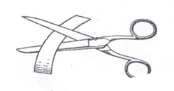

- With the help of arrows, show the position of the effort, the fulcrum and the load.
- To what class of levers do scissors belong?
………………………………………………………………………………………………………………………….
- To what group of simple machines does an axe belong?
………………………………………………………………………………………………………………………….
- State the law of moments.
………………………………………………………………………………………………………………………………………………………………………………………………………………………………………………………………
- Eric pushed a wheel barrow using a force of 25Newtons for a distance of 17metres.Calculate the work done by Eric.

Study the diagram below and answer the questions that follow

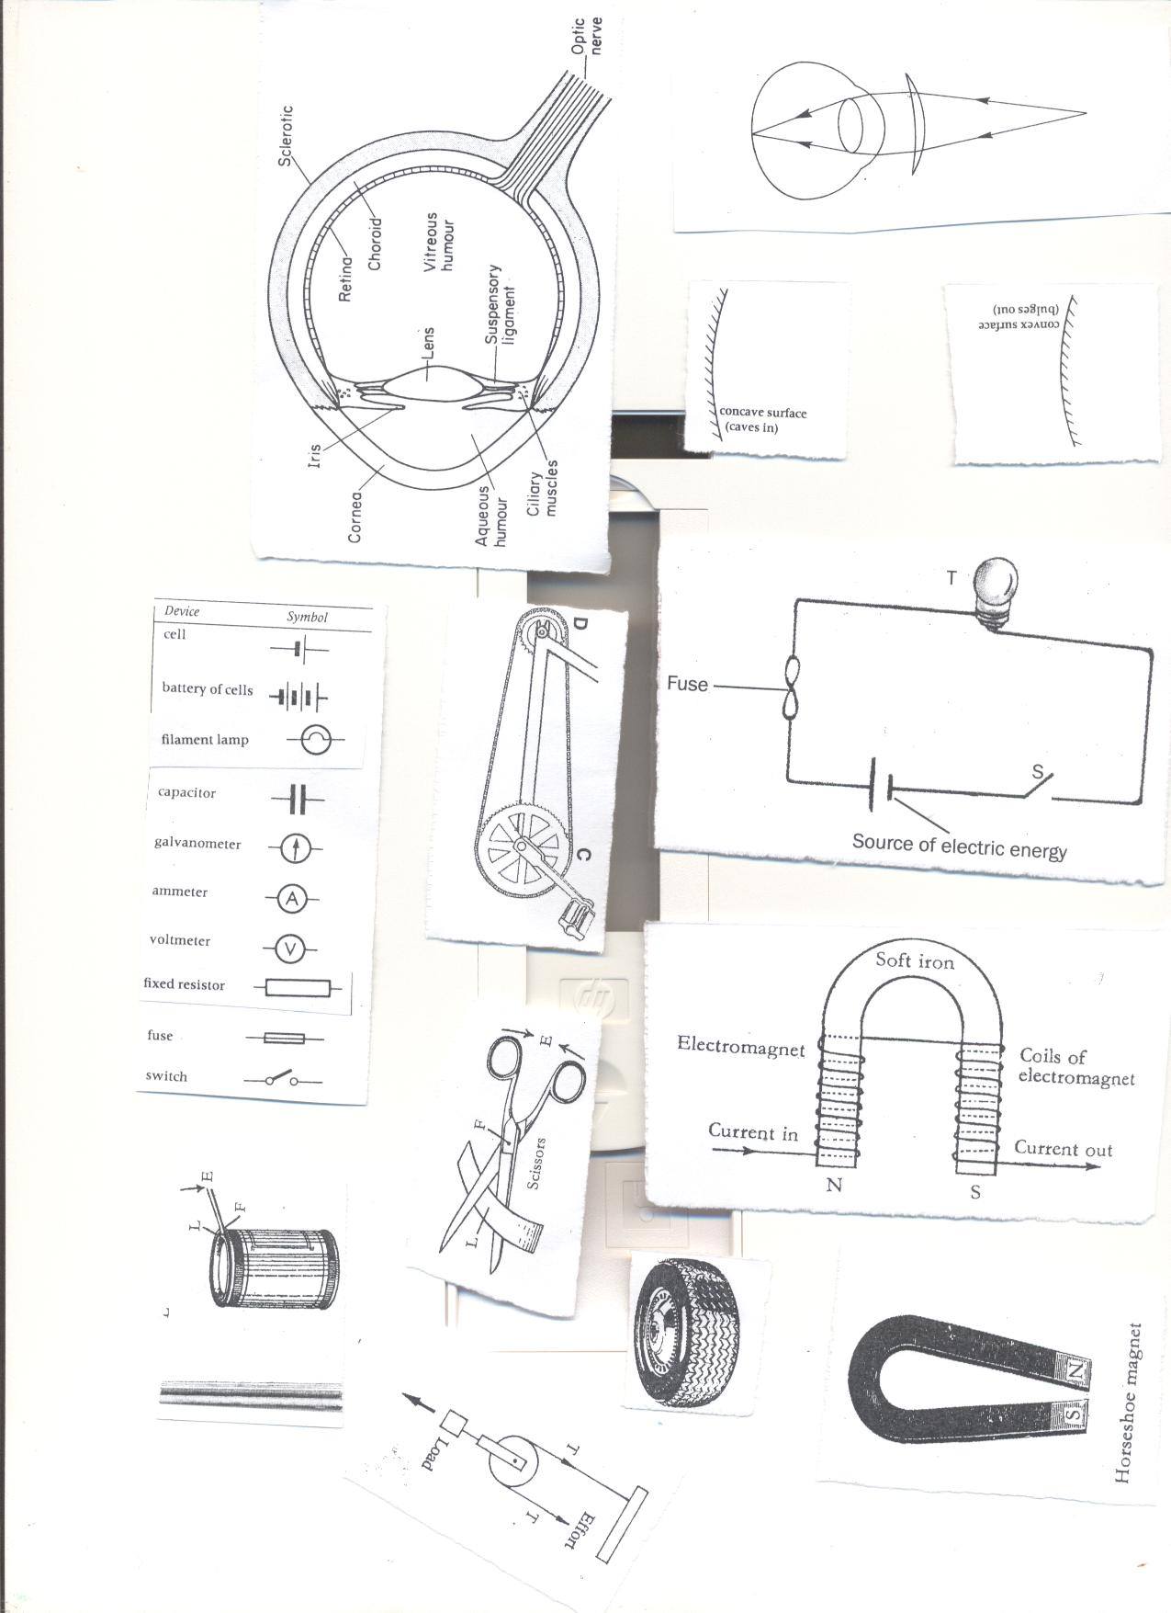
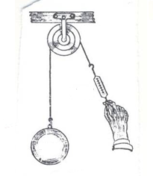
Y X

- Name pulleys X and Y
X: ………………………………………………………………………………………………………………………..
Y: ………………………………………………………………………………………………………………………..
- Which of the pulleys above needs less effort to raise a load of 60Newtons
……………………………………………………………………………………………………………………………
- Why should ball bearing be put in parts of a bicycle?
………………………………………………………………………………………………………………………………………………………………………………………………………………………………………………………………
- What is the function of an axe as a garden tool?
…………………………………………………………………………………………………………………………….
- What would happen to a tool like an axe if left in moist area?
………………………………………………………………………………………………………………………………
The diagram below shows a simple machine used to lift a load of 100kf with an effort of 50kgf

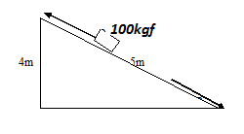

- Name the simple machine shown above.
………………………………………………………………………………………………………………………………
- What distance does
- Load move
……………………………………………………………………………………………………………………..
- Effort move
……………………………………………………………………………………………………………………….
- What can you do to use less than 50kgf to pull the same load?
………………………………………………………………………………………………………………………………
- Why are roads constructed with rough surfaces?
…………………………………………………………………………………………………………………………….
- Give any one use of a pulley at your school.
…………………………………………………………………………………………………………………………….

DAS__________
TOPICAL QUESTIONS FOR P.7 TERM 2 2019
SCIENCE NO. 5
School…………………………………………………………………………………………………………………
Name: ……………………………………………………………… Stream: …………………………………

TOPIC: EXCRETORY SYSTEM
- Define the term excretion
……………………………………………………………………………………………………………………………………………………………………………………………………………………………………………………………..
- State the main function of the kidney in the body.
……………………………………………………………………………………………………………………………………………………………………………………………………………………………………………………………..
- Where does filtration of blood to remove waste products take place in the kidney?
……………………………………………………………………………………………………………………………………………………………………………………………………………………………………………………………..
- List down any three components of urine.
- ……………………………………………………………………………………………………………………….
- ……………………………………………………………………………………………………………………….
- ………………………………………………………………………………………………………………………
- How is the medulla an important part of the kidney?
……………………………………………………………………………………………………………………………………………………………………………………………………………………………………………………………..
- State the role of the urinary bladder during excretion.
…………………………………………………………………………………………………………………………………………………………………………………………………………………………………………………………….
- Name the water borne disease which attacks the urinary bladder.
…………………………………………………………………………………………………………………………….
- Give anyone function of the human skin?
………………………………………………………………………………………………………………………………
- Why do soles of the feet develop thick surfaces after doing heavy manual work?
……………………………………………………………………………………………………………………………..

- State the two main layers of the human skin.
- ………………………………………………………………………………………………………………………
- ………………………………………………………………………………………………………………………
- What pigment determines the skin colour?
……………………………………………………………………………………………………………………………..

- How is the kidney similar to the skin in terms of function?
………………………………………………………………………………………………………………………………
- Give any two components of the sweat.
- ………………………………………………………………………………………………………………………
- ……………………………………………………………………………………………………………………….
- Write down any three diseases which attack the skin.
- ………………………………………………………………………………………………………………………
- ………………………………………………………………………………………………………………………
- ……………………………………………………………………………………………………………………..
- State the blood vessels which transports digested food materials from the ileum to the liver?
………………………………………………………………………………………………………………………….
- State the main function of the liver in the body.
……………………………………………………………………………………………………………………………
- Why are the lungs considered to be both excretory and respiratory organs?
…………………………………………………………………………………………………………………………..
- State the function of the celia found in the nostrils of humans.
………………………………………………………………………………………………………………………….
- Give the value of the epiglottis during digestion.
…………………………………………………………………………………………………………………………….
- Why are we advised not to breathe through the mouth?
…………………………………………………………………………………………………………………………….
- State the reason why the trachea is made of rings of cartilage.
……………………………………………………………………………………………………………………………
- By what process does gaseous exchange take place in the lungs?
…………………………………………………………………………………………………………………………..
- What important process takes place in the lungs?
……………………………………………………………………………………………………………………………
- How are the air sacs adopted to their function?
………………………………………………………………………………………………………………………………
- What happens to the diaphragm when we breathe in?
…………………………………………………………………………………………………………………………….

- Name any two non-infectious diseases of the lungs?
- ………………………………………………………………………………………………………………………
- ……………………………………………………………………………………………………………………..
- Identify any two ways of maintaining the health of the excretory system.
- …………………………………………………………………………………………………………………….
- ……………………………………………………………………………………………………………………..

DAS__________
TOPICAL QUESTIONS FOR P.7 TERM 2 2019
SCIENCE NO. 6
School…………………………………………………………………………………………………………………
Name: ……………………………………………………………… Stream: …………………………………

TOPIC: LIGHT
- Name one natural source of light.
…………………………………………………………………………………………………………………………….
- Give one difference between luminous and non-luminous object.
…………………………………………………………………………………………………………………………….
- Identify the materials which;
- Do not allow any light reaching them to pass through them
……………………………………………………………………………………………………………………….
- Allows some light to pass through them
……………………………………………………………………………………………………………………..
- Briefly explain how a solar eclipse is formed.
……………………………………………………………………………………………………………………………..
- How is a shadow formed?
………………………………………………………………………………………………………………………………
- State the difference between reflection and refraction?
………………………………………………………………………………………………………………………………
- In the space provided below draw to show the difference between a converging and diverging beam of light?

- What is the function of the sun in rainfall formation?
…………………………………………………………………………………………………………………………….

- Complete the diagram below correctly
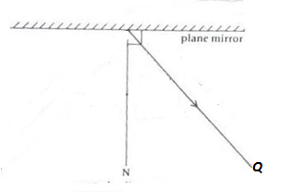

- Name the ray marked Q
…………………………………………………………………………………………………………………………..
- State anyone law of reflection?
…………………………………………………………………………………………………………………………….
- How do images formed in pin hole camera differ from those in a plane mirror?
…………………………………………………………………………………………………………………………….
- Describe an experiment to show that light travels in a straight line.
…………………………………………………………………………………………………………………………….
- Why aren’t able to be around corners?
……………………………………………………………………………………………………………………………..
- During a thunder storm, why is light seen before sound is heard?
……………………………………………………………………………………………………………………………..
The diagram shows two different lenses, use them to answer the questions that follow
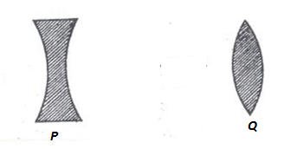

- Name the lenses marked P and Q
P …………………………………………… Q ………………………………………………………..
- What type of beam does lens Q produce when a parallel beam passes through it?
………………………………………………………………………………………………………………………………
- The eye defect corrected by the lens marked by P and Q
P …………………………………………….. Q ………………………………………………………………
- Name anyone eye disease caused by bacteria ………………………………………………………………………………………………………………………………
- What causes refraction of light? ………………………………………………………………………………………………………………………………
- What is dispersion of light? ………………………………………………………………………………………………………………………………
- Why does a green mug appear green? ………………………………………………………………………………………………………………………………

DAS___________
TOPICAL QUESTIONS FOR P.7 TERM 3 2019
SCIENCE NO. 7
School…………………………………………………………………………………………………………………
Name: ……………………………………………………………… Stream: …………………………………

POPULATION AND HEALTH
- Define the term human population? ………………………………………………………………………………………………………………………………
- Write down any four health concerns common in your area? ………………………………………………………………………………………………………………………………
- Identify any three human activities that can lead to poor sanitation. (i)……………………………………………………………………………………………………………………………
(ii) …………………………………………………………………………………………………………………………
(iii) …………………………………………………………………………………………………………………………
- Give any two causes of sickness in a home.
(i) ………………………………………………………………………………………………………………………….
(ii) …………………………………………………………………………………………………………………………
- Write two activities which can improve sanitation at home?
(i)……………………………………………………………………………………………………………………………
(ii)…………………………………………………………………………………………………………………………..
- State three common anti-social behaviours in a school?
(i) …………………………………………………………………………………………………………………………
(ii) ………………………………………………………………………………………………………………………….
(iii) …………………………………………………………………………………………………………………………
- Give any two natural changes which can result into insufficient food supply in a community?
(i) ………………………………………………………………………………………………………………………….
(ii) ………………………………………………………………………………………………………………………….
- Identify any two ways how the government of Uganda has tried to improve on provision of clean water supply in your community?
(i) ………………………………………………………………………………………………………………………….
(ii) ………………………………………………………………………………………………….........................

- What health problems can result from poor water supply in your area? ………………………………………………………………………………………………………………………………………………………………………………………………………………………………………………………………………………………………………………………………………………………………………………………………
- Outline two ways how we can promote health in a community?
(i) …………………………………………………………………………………………………………………………
(ii) ………………………………………………………………………………………………………………………….
- Give any two values of budgeting in a family? (i)……………………………………………………………………………………………………………………………
(ii) ………………………………………………………………………………………………………………………….
- State any two values of healthsurveys on area (i)……………………………………………………………………………………………………………………………(ii)…………………………………………………………………………………………………………………………
- Define the term demography as used in health education. ………………………………………………………………………………………………………………………………………………………………………………………………………………………………………………………………
- Identify anyone health danger of staying in overcrowded areas? ………………………………………………………………………………………………………………………………
- Give any two reasons why immunization of children is important? (i)……………………………………………………………………………………………………………………………(ii)…………………………………………………………………………………………………………………………..
- State the importance of a child health card to;
- Parent ……………………………………………………………………………………………………………………………………………………………………………………………………………………………………………….
- Doctor ……………………………………………………………………………………………………………………………………………………………………………………………………………………………………………….
- School health committee ……………………………………………………………………………………………………………………………………………………………………………………………………………………………………………….
- Why should an expectant mother be immunized with tetanus toxoid? ………………………………………………………………………………………………………………………………………………………………………………………………………………………………………………………………
- How is a health centre important to people in the community? ………………………………………………………………………………………………………………………………………………………………………………………………………………………………………………………………

DAS___________
TOPICAL QUESTIONS FOR P.7 TERM 3 2019
SCIENCE NO. 8
School…………………………………………………………………………………………………………………
Name: ……………………………………………………………… Stream: …………………………………

TOPIC: INTERDEPENDENCE OF LIVING THINGS
- Define the term environment? ………………………………………………………………………………………………………………………………………………………………………………………………………………………………………………………………
- Give anyone living component of the environment? ………………………………………………………………………………………………………………………………
- Define the term interdependence? ………………………………………………………………………………………………………………………………………………………………………………………………………………………………………………………………
- What is a resource? ………………………………………………………………………………………………………………………………………………………………………………………………………………………………………………………………
- Identify any three resources from the environment. (i)……………………………………………………………………………………………………………………………(ii)…………………………………………………………………………………………………………………………..
(iii)………………………………………………………………………………………………………………………….
- Give any two ways in which living things depend on nonliving things?
- (i)……………………………………………………………………………………………………………………………………………………………………………………………………………………………………………………………(ii)…………………………………………………………………………………………………………………………………………………………………………………………………………………………………………………………
- Identify two ways how animals depend on plants? (i)……………………………………………………………………………………………………………………………………………………………………………………………………………………………………………………………
(ii)…………………………………………………………………………………………………………………………………………………………………………………………………………………………………………………………

- Give three ways in which plants benefit from animals? (i)……………………………………………………………………………………………………………………………………………………………………………………………………………………………………………………………(ii)…………………………………………………………………………………………………………………………………………………………………………………………………………………………………………………………(iii)…………………………………………………………………………………………………………………………………………………………………………………………………………………………………………………………
- How do animals depend on each other? ………………………………………………………………………………………………………………………………………………………………………………………………………………………………………………………………
- How do plants depend on plants? ………………………………………………………………………………………………………………………………………………………………………………………………………………………………………………………………
- Study the organisms below and answer the questions that follow
Plant insects lizards hawks bacteria sun

- What is the main role of the sun in the food chain? ………………………………………………………………………………………………………………………………
- State one reason why plants are considered as producers? ………………………………………………………………………………………………………………………………………………………………………………………………………………………………………………………………
- What scientific term best describes lizards in the food chain above ………………………………………………………………………………………………………………………………
- What is agro- forestry? ………………………………………………………………………………………………………………………………
- State anyone reason why people plant trees in their compounds? ………………………………………………………………………………………………………………………………………………………………………………………………………………………………………………………………
- State the importance of agro – forestry to the farmer? ………………………………………………………………………………………………………………………………………………………………………………………………………………………………………………………………
- Give any two qualities of good seeds or cuttings to be planted? (i)……………………………………………………………………………………………………………………………(ii)…………………………………………………………………………………………………………………………..
- How does mulching improve soil fertility? ………………………………………………………………………………………………………………………………………………………………………………………………………………………………………………………………
- How are sweet potatoes propagated? ………………………………………………………………………………………………………………………………

- Give any two ways farmers can care for their trees in the garden? (i)……………………………………………………………………………………………………………………………(ii)…………………………………………………………………………………………………………………………..
- Why do some trees need pollarching? ………………………………………………………………………………………………………………………………………………………………………………………………………………………………………………………………
- Identify any three methods of harvesting wood (i)……………………………………………………………………………………………………………………………(ii)…………………………………………………………………………………………………………………………
(iii)…………………………………………………………………………………………………………………………
- Give two methods of planting crops? (i)……………………………………………………………………………………………………………………………(ii)…………………………………………………………………………………………………………………………..
- How do trees planted in a school garden prevent soil erosion? ………………………………………………………………………………………………………………………………………………………………………………………………………………………………………………………………
- Write down any three common trees planted for provision of hard wood?
(i) ………………………………………………………………………………………………………………………….
(ii) ………………………………………………………………………………………………………………………….
(iii) …………………………………………………………………………………………………………………………
- State the value of a nursery bed on a school farm? ………………………………………………………………………………………………………………………………
- List down any two effects of crop pests to our produce? (i)……………………………………………………………………………………………………………………………
(ii) ………………………………………………………………………………………………………………………….
- Match items in list A with those in list B
A B
Cassava American boll worm
Banana mosaic
Ground nuts panama
Maize rosette disease
Streak disease

